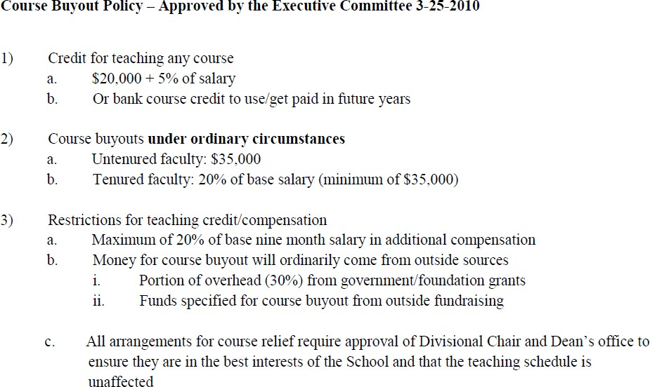

Course Buy Out Procedure November 2020

- Faculty member requests a course buy out (fills out attached form and gets signatures or e-mail approvals.)
- Approval solicited by faculty member and received from Divisional Chair
- Approval solicited by faculty member and received from Senior Vice Dean of Faculty Affairs
- Amount of buyout funds agreed upon by Senior Vice Dean of Faculty Affairs and Faculty Member based on policy: http://www4.gsb.columbia.edu/filemgr?file_id=7214690 (see screen shot below)
- Account /chart-string to charge identified and authorized by responsible party.
- Course Buy Out - Fund Transfer Request sent to Financial Planning by Dean’s Office to make transfer
- Course Buy Out - Fund Transfer Request Processed sent to Senior Administrative Manager and Divisional Coordinator to log in the Teaching Credit Database.
- Completed forms will be archived in the Teaching Credit Database.

Course Buy Out Approval and Fund Transfer Request Form
A “course buyout” is an agreement that reduces the number of courses that a faculty member will teach in a given year. A “course buyout” does not represent a reduction in course load, but indicates that an alternate funding source will reimburse the School to compensate for a course that a faculty member would otherwise be obligated to teach. The agreement must be approved by the funding source, the department chair, the dean’s office, and the faculty member. This form documents that agreement, and facilitates the appropriate fund transfer.

 | Please Print |  | Approval Signature / Date
Faculty Member Name
(Last, First)
Faculty Member Division
Semester and Year (eg Fall 2012)
Course Name and Number
Teaching Credits (1 or 0.6)
Approval of Division Chair
Approval of Senior Vice Dean
Cost of Buyout (Salary + Fringe)
Account Number to Charge
Account Number Approver
Chart String to Credit  GLUnit: COLUM  PC BU: GENRL  Project: UR004295  Activity: 01  Initiative: 00000  Segment: 00000000 | Acct: | Dept: 5110102
 | DRO: | Dept: 5110502
 | Econ: | Dept: 5110702
 | Finance: | Dept: 5110202
 | Mgmt: | Dept: 5110402
 | Mrkt: | Dept: 5110302
Processed by Financial Planning
Documented by Division
Documented by Senior Administrative Manager in the
Dean’s Office

