

**Doctoral Students Progress Tracking Spreadsheet & Progress Documents**

**Overview**

This document is intended to explain the basics of the new Doctoral Students Progress Tracking Spreadsheet so that authorized users can get information and collaborate without introducing errors into the data.

**Organization**

Each division has a PhD folder on the W drive named phd_deptname_share and in the folder there is:

* one excel document with all division’s students on the first page, and a tab for each student
* a folder for each student (to be created)

**Naming Conventions**

Within the folder for each student, please use the following naming conventions for the documents:

* Lastname,Firstname_1summer
* Lastname,Firstname_2summer
* Lastname,Firstname_3report
* Lastname,Firstname_4report
* Lastname,Firstname_DissertationProposal
* Lastname,Firstname_DissertationDraft(1)
* Lastname,Firstname_DissertationFinal
* Other

Links to these links can be embedded in the Excel spreadsheet by right clicking on the cell, selecting hyper link, and navigating to the file.

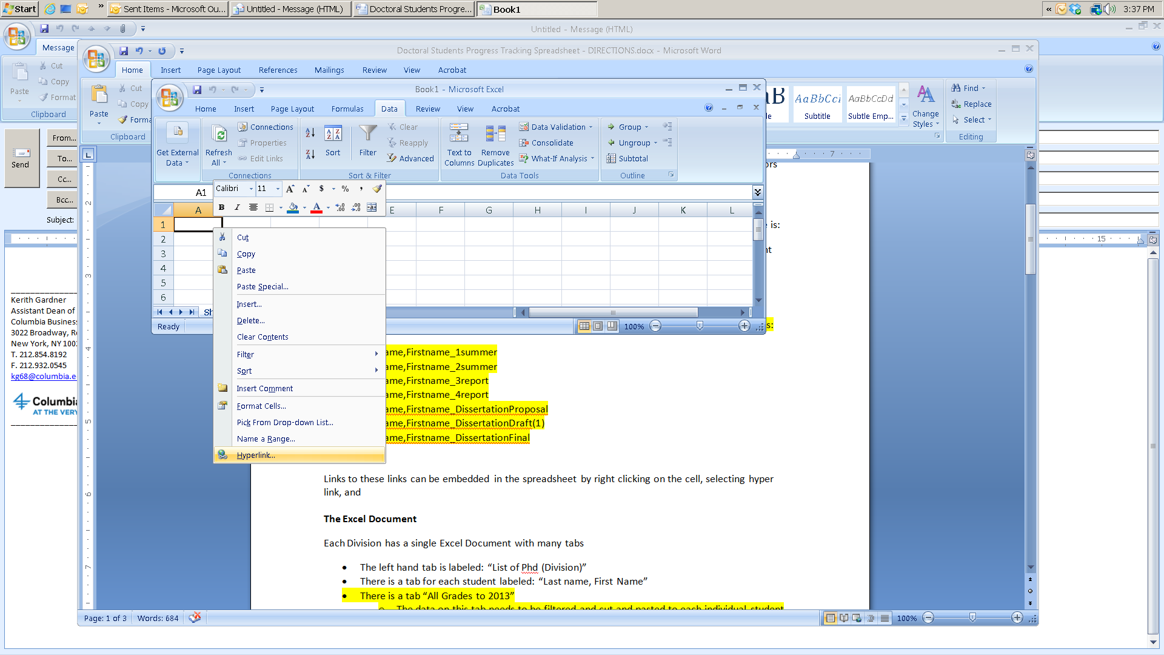

**The Excel Documents**

Each division has its own spreadsheet in its own folder and in the PhD All Share folder, there is a summary version of the spreadsheet.

**Data changes should be made on the divisional and individual student spreadsheets**

**Do not make any changes on the “List of All Doctoral Students” tab of the SUMMARY document.** Everything on that document it flows directly from the Divisional sheets. If you need to make a correction, do it on the divisional sheet.

When new students get added in 2014-2015, you can add those students to the list, but otherwise, don’t make any changes.

There is also a “Summary Statistics” tab in this document. It has several pivot tables on it, and we can add more if you need them.

By clicking on the “refresh data” button on the data tab, all information changed in the divisional sheets will be updated in the pivot tables, so once the status of students is documented, it will be simple to track progress.

Each Division has a single Excel Document with many tabs

1. The left hand tab is labeled: “List of Phd (Division)”
2. There is a tab for each student labeled: “Last name, First Name”
3. There is a tab “All Grades to 2013”
   * The data on this tab needs to be filtered and cut and pasted to each individual student page to exactly match the page of first student in the accounting division’s “Aghamolla, Cyrus” individual page.
   * It is critical to copy the top line and filter and place the data in exactly the same place on every individual student’s page, starting in cell A13 or the calculations won’t work.
   * The RA/Staff person also needs to paste forur more cells x and Y 9 and 10 (copied again from the “Aghamolla, Cyrus” page to calculate the GPA.
   * In addition, cell B10 needs to be replaces with the following =Y10/X10



Note to Costis, I have done this for “Crapis, Davide” so you can edit his progress and see how it all flows through.

1. There is a tab labeled GPA Equivalents – this is used to look up the numeric equivalent of the grade which is then incorporated into the GPA calculation. Please leave it alone.

**Data In the Excel Document**

Bright Green fields calculate by themselves or draw data from other sheets – please do not change the formulas in them, or the information will not calculate.

**If you want to make changes to the record of a particular student**, please go to their individual page where you can track their progress by looking at the courses taken (in lines 13 and below) and can enter data in line 10 about their academic progress – specifically the following items using the embedded drop down menus:

* # courses completed in other divisions
* 2 courses completed in other divisions
* Qualifying Exam (1) Outcome (1st time)
* Qualifying Exam (1) Outcome (2nd time)
* Qualifying Exam (2) Outcome (1st time)
* Qualifying Exam (2) Outcome (2nd time)
* Qualifying Exam Requirement to pass
* Field Exam passed
* Mphil Degree Conferred
* Dissertation Proposal Submitted
* Oral Exam Passed
* Dissertation Defended
* Degree Granted

The information on progress that you enter in line 10 flows through to the “List of PhD” page, where one can see the status of the entire division.

ID information and links to student documents (once established) are included on the “List of PhD” page.

**To Do List**

**Staff or RA:**

1. Set up a folder for each student in the appropriate divisional folder
2. Using naming conventions above, file all appropriate documents completed to date for each student
3. On each Divisional Spreadsheet:
   * Go to the All Grades sheet
   * Filter by one student’s name at a time, and for each student, copy all of the classes from the “all Grades” page to the individual student page. Be sure to include the labels under the course row on the individual page.
4. The GPA calculation is imperfect because some classes have no grades. You can either repeat this on all pages or can just add in the GPA as calculated by SIS by hand.
   * Add the calculating fields and labels from the“Aghamolla, Cyrus” page to calculate the total credits and the total grade weight.
   * Then In cell B10 type =Y10/X10 to calculate the GPA.
5. On the “List of Phd” summary sheet for each division, add in the gender and ethnicity of each student

**After the course data has been pasted on each students page:**

**For Doctoral Program Leadership**

Go to the page for each student who they are advising. Review the courses completed and enter the appropriate data in the row 10 and document academic progress on the following dimensions.

* # courses completed in other divisions
* 2 courses completed in other divisions
* Qualifying Exam (1) Outcome (1st time)
* Qualifying Exam (1) Outcome (2nd time)
* Qualifying Exam (2) Outcome (1st time)
* Qualifying Exam (2) Outcome (2nd time)
* Qualifying Exam Requirement to pass
* Field Exam passed
* Mphil Degree Conferred

Develop a convention for notes and comments—either on the individual page or in a separate word document in the student’s folder (probably the easiest.)