FADS, FASHIONS AND THE FLUIDITY OF KNOWLEDGE:
THE STORY OF PETER SENGE’S "THE LEARNING ORGANIZATION"

CHAPTER OUTLINE:
This chapter uses the story of Peter Senge’s The Learning Organization (TLO) and talks about "learning organizations” to illustrate how management fads and fashions affect the spread of knowledge. Some commentators labeled Senge’s successful TLO work a “fad.” Implicit in such labeling is derision and suggestion that association with TLO lacks benefit. New management techniques often provoke skepticism and when miracles do not occur, receive the same derogatory “fad” label. Is the negativism associated with management fads and fashions warranted? Analysis of the Senge TLO phenomena portrays fads and fashions as social processes, intrinsic to social change. They erupt from latency periods and may have brief or long lives. In retrospect, their consequences may be beneficial or harmful and may be short-term or long-term. Even brief fads may produce lasting benefits. TLO's story shows the complexity of social change and reveals the fluidity of knowledge, as ever-evolving fads and fashions weave older ideas into new beliefs and ways of problem solving.
Introduction
An organization’s ability to learn, and translate that learning into action rapidly, is the ultimate competitive advantage. – Jack Welch
Peter Senge's 1990 book “The Fifth Discipline: The Art and Practice of the Learning Organization” presented a compelling frame for a collection of ideas and gave structure to a “new” TLO concept. Senge explained that people need to conceive of the world as systems on which humans have imposed structures that both serve purposes and impose constraints. Senge explained TLO as a process of understanding and continually working to master five important disciplines. Each discipline has at its core a critical truth about a learning organization and adds to the total meaning of TLO. Senge’s rich book was highly successful and attracted enthusiasts. Yet, now 20 years later, many commentators were dismissing TLO as a fad. This chapter evaluates Senge’s TLO story and uses it to consider the contribution of fads and fashions to knowledge creation.
TLO is more than just a set of ideas promoted by a specific individual. Although TLO gained much impetus from its active champion, its emergence followed a latency period. Senge did not invent his concept of TLO out of nothing. He pulled together ideas that had originated separately in various places over several decades. Even the specific term "the learning organization" had appeared in print earlier (Garratt, 1987; Korten, 1980). The success of Senge's book was partly a result of its timing. Senge spotted a developing societal trend, identified some relevant concepts, placed these concepts into a frame, and made the concepts accessible by retelling familiar stories and presenting interesting examples. Sales of Senge's books, public accolades, and formation of at least two societies testify that growing acceptance of TLO as valuable knowledge had widespread social support. Some consultants have promoted efforts to apply Senge's prescriptions, and some organizations may have benefited from trying to apply them.
This chapter describes the history of TLO and Senge’s role in its emergence as a mainstream concept. This history suggests two questions. Why did Senge’s book become popular and retain this popularity through two editions and two decades? Was the popularity of this book a consequence of its inherent properties or of its societal context? The chapter addresses these questions by drawing upon research into fads and fashions in business techniques. This research suggests that suppliers of management techniques – academics, consultants – promote them as efficient means to effective ends and also as novel and improved. By framing reactions to TLO in terms of prior research about fads and fashions, the chapter also raises questions about the nature of knowledge and what "learning" means.
The Success of Senge’s TLO
Peter Senge's The Fifth Discipline drew millions of readers and popularized the TLO concept. The book presented five techniques or “disciplines” that Senge said “must be studied and mastered to be put into practice” within a TLO (1990: 10). Senge defined TLOs as
organizations where people continually expand their capacity to create the results they truly desire, where new and expansive patterns of thinking are nurtured, where collective aspiration is set free, and where people are continually learning how to learn together.
The book sold over 2.5 million copies, a result that encouraged Senge to say more about TLO. Over the following decade, he provided examples of the application of TLO principles in different contexts. In 1994, he and colleagues published The Fifth Discipline Fieldbook: Strategies and Tools for Building a Learning Organization. It has sold over 400,000 copies. A second fieldbook came out in 1999 under the title The Dance of Change: The Challenges to Sustaining Momentum in Learning Organizations. In 2000, Senge co-authored schools that learn: A Fifth Discipline Fieldbook for Educators, Parents and Everyone Who Cares about Education. A revised version of the original Fifth Discipline book appeared in 2006.
Senge created a compelling vision. Jackson (2000: 207) claimed the TLO concept had dramatic qualities and inspired “followers to see themselves actively engaged in building a learning organization.” As popularity of TLO concept quickly grew, Senge founded a Center for Organizational Learning at MIT in 1991. Emerald Group Publishing launched a journal named The Learning Organization in 1994. Several prominent business magazines, including Business Week and Fortune, published articles about TLO. In 1997, Harvard Business Review named The Fifth Discipline as one of the most influential management books in the last 75 years. Also in 1997, Senge formed the Society for Organizational Learning, which subsequently spawned a journal entitled Reflections: The SoL Journal and which has developed consulting, coaching, conference and publishing initiatives for its members. In 1999, the Journal of Business Strategy included Senge among the 24 people who had exerted the greatest influence on business strategy during the twentieth century. In 2000 and 2001, the Financial Times and Business Week called him one of the world's "top management gurus."

Figure 1 shows the numbers of documents that cited The Fifth Discipline from 1990 through 2005. The graph terminates in 2005 because more recent data are less and less complete, so trends tend to appear to indicate that citations are leveling off or declining near the time of data gathering. Very likely, citations have continued to increase since 2005. Three fields account for 98% of the documents that cited The Fifth Discipline. Documents classified by Google as "social science," which accounted for 49% of the citations, have mainly discussed educational organizations. Documents classified as "business" have generated an additional 41% of the citations. Documents classified as "engineering," which supplied an additional 8% of the citations, have mainly discussed information systems.

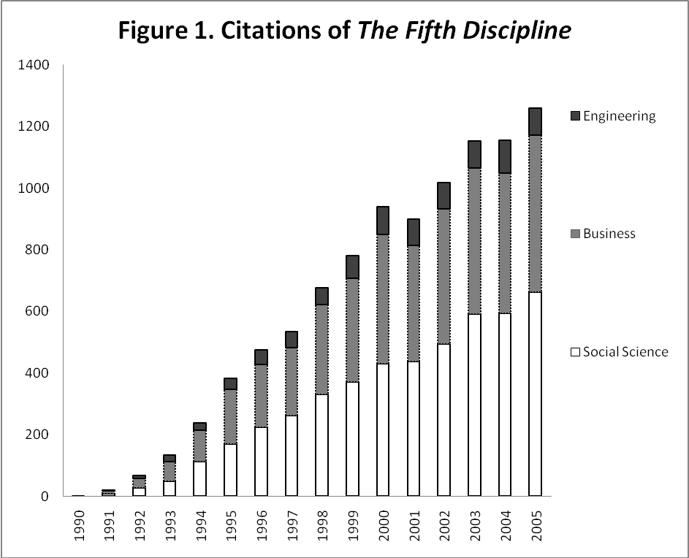

Citations to the journal named The Learning Organization have also continued to increase. Indeed, articles published by this journal have had surprisingly long citation lives. A typical article from the early issues received less than half of its total citations during the first nine years following publication, and the articles published in the journal's first year were still receiving approximately one citation a piece per year, sixteen years later.
TLO's Latency Period
Research indicates that fads and fashions in business techniques typically have latency periods during which the techniques have little popularity (Abrahamson and Eisenman, 2008). Latency may give way to sudden upswings in techniques’ popularity followed by equally sudden downswings, resulting in waves of diverse amplitudes and durations (Carson, Lanier, Carson, and Guidry, 2000). Some ideas may achieve wide acceptance and popularity; other ideas fail to gain much attention.
Both academic and nonacademic writers had been discussing components of Senge's TLO for several decades, an emergence and sudden surge in popularity could have occurred earlier. They did not. Senge’s book could have been yet another incremental contribution to a continuing latency period. It was not. Instead, Senge brought TLO to prominence. Why Senge? Why his book? Why in 1990?
TLO and its five component disciplines build on a wide range of prior conceptual developments. Predecessor thinking concerns organizational learning, organizational rigidity, learning systems, systems thinking and even prior discussions of similarly described “learning organizations.” Senge devoted large portions of The Fifth Discipline to the ideas of other people. Table 1 shows the antecedents on whom Senge relied most strongly; they include both academics and practitioners.
Insert Table 1 here.
Although Senge gave credit to the works listed in Table 1, he did not mention much of the research that had preceded his book. Even without attribution, current knowledge builds on prior knowledge. Sometimes similar ideas develop in different camps from a common pool of information, then proceed along different trajectories. Invention races and first-to-invent claims made by individuals in different parts of the world occur often. Senge’s TLO draws from a wide range of prior knowledge concerning systems and organizational learning. Many other thinkers were on tangent paths. For instance, Senge did not report that, fifteen years earlier, Hedberg, Nystrom and Starbuck (1976: 43) had written about how to keep organizations from rigidifying over time and how to foster continuing development. They argued, “Designs can themselves be conceived as processes – as generators of dynamic sequences of solutions, in which attempted solutions induce new solutions and attempted designs trigger new designs.”
Academic studies of organizational learning. As early as 1936, engineers and economists noticed that the costs of producing aircraft grew less as workers produced more aircraft (Argote, 1999). By the early 1950s, academic economists and management scholars were debating the possible influence of evolutionary selection on decision making in populations of business firms (Salgado, Starbuck, and Mezias, 2002). A decade later, Cyert and March (1963) wrote about adaptive learning by individual organizations. They characterized organizational learning as adapting decision rules to circumstances, changing goals and forecasts to reflect experience and updated perceptions, modifying goals to make them more realistic, and searching where previous searches have brought success. Such ideas have subsequently spawned many research studies and generated considerable debate. These studies indicate that organizational learning is deceptively treacherous and very likely to disappoint the learners.
Research studies indicate that the efforts of individual organizations to adapt to their environments are generally inadequate and frequently erroneous. Lessons that prove valuable in the short run tend to prove harmful in the long run (Hedberg et al., 1976). Unpredictable environmental changes may reward organizations that have acted incompetently or ineffectively (Starbuck and Pant, 1996). Intra organizational politics and careerism may suppress evidence of poor performance and create false evidence of success (Baumard and Starbuck , 2005). Because organizations imitate each other, gains that organizations make vis-à-vis their competitors disappear rather rapidly (Simon and Bonini, 1958). Thus, some researchers have pursued the hypothesis that organizational learning is primarily a population-level phenomenon: evolutionary variation and selection might change the kinds of organizations that exist even if individual organizations change very little. However, over a decade of empirical studies showed that changes in organizational populations look very like random walks (Carroll, 1983; Levinthal, 1991). After more than fifty years of thought and study about organizational learning, March (2010: 114) surmised: "Much of organizational and managerial life will produce vividly compelling experiences from which individuals and organizations will learn with considerable confidence, but the lessons they learn are likely to be incomplete, superstitious, self-confirming, or mythic."
Nonacademic writing about organizational learning. Some of the people who have been working to facilitate organizational learning give credit to Revans, who wrote about “The enterprise as a learning system” (1982). In parallel with Bohm, Argyris and Schön, on whom Senge relies heavily, Revans argued that organizations should not rely on "experts" for advice and that groups of organization members should discuss their own actions and experiences in a process he called Action Learning.
At least two authors used the exact term "the learning organization" before Senge did, and David Korten (1980) used it a full decade earlier. Korten described five development projects in the Third World, and then argued that such projects should not adhere to plans that were designed top-down but should develop bottom-up through participation by people who understand events at first-hand. There will always be errors, and a learning organization should welcome evidence about errors as guidance about how to perform better. A learning organization also involves local people, takes advantage of what they know, and uses resources that are readily available. A learning organization integrates research, planning, and implementation. However, Korten was clearly talking about development projects that had rather specific goals and rather temporary lifespans rather than learning that might go on indefinitely.
In a book titled The Learning Organization, Bob Garratt (1987) argued that business organizations typically have too little open discussion of issues, with one result being too little reflection about policies and strategies, and another result being too little information input from business environments. Garratt saw organizational learning as being the special responsibility of senior managers, and he proposed that senior executives ought to devote more effort to their personal learning and they should try to guide their organizations' continuing development.
In a third work titled The Learning Company, Pedler, Burgoyne, and Boydell (1988) sought to identify properties of "an organization that facilitates the learning of all its members and consciously transforms itself and its context." They pointed to eleven properties that would enable such learning. These properties included strategizing as a learning process, wide participation by organization members and stakeholders, a culture that encourages continuous learning, and helpful accounting and information systems.
Clearly, both the term "the learning organization" and the ideas echoed in The Fifth Discipline were well-known in the 1980s, especially the late 1980s. Yet, it was Senge’s interpretation of TLO that caught on and began to spread (Jackson, 2000).
Senge's Focus
Although Senge acknowledged that he was not the first person to write about organizational learning, his presentation seems to imply that his ideas have broader relevance than prior perspectives. Of course, he may have been unaware of the earlier research about organizational learning. He could have used the prior research he ignored to bolster his case for the need to approach organizational learning differently. The very fact that most organizational learning is ineffective or eventually causes problems gives reason for readers to pay attention to new ideas. At the same time, Senge's lessons do not focus on the kinds of organizational learning that typically do occur. He is not naïve and he recognizes that human behavior often impedes learning and that much organizational learning goes amiss. He is proposing that a more effective kind of learning could be occurring. He is a visionary who is trying to describe an idealized organizational form that does not exist today but, he says, could exist in the future.
What Senge Said, How He Said It
The Fifth Discipline has unusual properties. This fact should surprise no one, of course, because the book has had extreme success far beyond that of almost all other books. Even if the book's success is partly due to its timing and environment, it is unlikely to look exactly like less successful books. However, the book has properties that make it both attractive and unattractive to readers. Some evidence suggests that The Fifth Discipline is both easy to read and yet unread, that its popularity derives in part from its appeal for readers who see themselves as unusual, that its ideas have rarely been implemented and implementation has yielded unclear results. Does The Fifth Discipline afford a prototype for other books that aim at societal influence? Or, has The Fifth Discipline succeeded because of its timing and despite its idiosyncrasies?
Much of The Fifth Discipline is very easy to understand, down-to-earth, and practical. Within the general themes, the text is fragmented and episodic. This fragmentation of text allows readers to read and digest segments. One need not read an entire chapter, sometimes not even an entire page, in order to extract a distinct point. Many of the segments tell great stories about human behavior, restate truisms, or contain quotable phrases. Although these segments fit into Senge's broader themes, they also stand alone as epigrams or illustrations of specific lessons (Ortenblad, 2007). For example, time delay in physiological reactions to ingesting food causes people to eat too much; trying to swim against a strong current may sap a swimmer's strength without producing progress toward shore. Such illustrations let readers draw useful lessons whether or not they buy into Senge's broader themes, and they make the lessons easy to remember. At the same time, the broader themes give the book some coherence and create an impression of communicating a message of grand significance.
However, the book also forwards ideas that are so abstract that many people do not see their value and the ideas are difficult and expensive to implement (Smith, 2008). The book offers rhapsodic discussion of interlinked systems, their importance and prevalence. It recognizes the complexity of organizational and behavioral challenges. It advocates holistic and dynamic appreciation of social systems (including organizations), and it criticizes much management practice as misguided efforts to apply simplistic mental frameworks to complex situations. Effective management, it says, requires "systems thinking" – appreciation for interdependencies and change over time. It (1990:14) asserts that effective organizational learning involves creativity as well as adaptation: "it is not enough to survive. ‘Survival learning' or what is more often termed 'adaptive learning' is important – indeed it is necessary. But for a learning organization, 'adaptive learning' must be joined by 'generative learning', learning that enhances our capacity to create". Indeed, Senge concluded The Fifth Discipline with titillating predictions about a “sixth discipline.” In an obscure manner, he suggested that an intellectual sequel awaits once the first five disciplines reach critical mass. Senge (1990: 363) predicted, “there will be other innovations in the future” and “perhaps one or two developments emerging from seemingly unlikely places, will lead to a wholly new discipline that we cannot even grasp today.”
Of course, his conceptual framework implies that Senge's prescriptions are themselves interdependent and idealistic. He urges people to practice five "disciplines", which Table 2 summarizes. The disciplines deal with individuals, groups, and whole organizations, and they overlap each other to some degree. Indeed, this overlap contributes to making the book very dense and difficult to synthesize. For example, in his discussion of systems thinking, Senge explains that the mental models are in many ways the results of the structures people impose on systems. In their efforts to understand and manage systems, people break systems down into more manageable pieces, organize them into structures and then interpret them in these fragmented and organized forms. The structures may be literal but they are more often concepts about processes, procedures, or hierarchies. These imposed structures alter understandings of the entire system, often making the understandings less accurate. The structures also make systems more complex and hinder people's ability to learn. Thus, Senge prescribes awareness, reassessment of goals, and open exchange of ideas – individual and group actions – to improve system-wide learning.
Insert Table 2 here.
Much of The Fifth Discipline is bizarrely abstract, nearly impossible to decipher, and impossible to translate into practical actions. People who have tried to use Senge's ideas have raised questions about The Fifth Discipline's practical implications. Malone (1997: 72) pointed to three problems: (1) TLO had turned into training; (2) TLO had slipped into an MIS sinkhole; (3) “No one has yet figured out quite how an organization ‘learns’ the right things.” Smith (2001) suggested that Senge’s work was “simply too idealistic” and he observed that the self-reflection associated with the five disciplines daunts most people; many employees just want to earn a living and have no interest in the greater ideals of the organization. Ortenblad (2007) reported that managers do not read the book because it is so difficult to read and he complained that Senge provided no blueprint for implementation. Senge himself has expressed disappointment that companies “either paid no more than lip service to [The Fifth Discipline] or turned their backs on it altogether” (Senge and Crainer, 2008: 71). In 2008, The Learning Organization journal published a 15-year retrospective issue on both TLO concept and on the journal itself. The editor concluded that “although the learning organization concept is deemed narrow and out of date, it is judged to have significant positive influence on organizational thinking” (Smith, 2008: 441).
The foundation of TLO – systems analysis – may be its weakest component. The Fifth Discipline describes ten systems archetypes, which Senge characterized as tools to help managers learn systems thinking. The archetypes mix heterogeneous elements at different levels of abstraction – simplistic explanations involving phenomena such as delay and eroding goals alternate with complex theoretical descriptions such as the “tragedy of the commons” and “growth and underinvestment.” The conglomerate character of these archetypes underscores the substantial challenge of overcoming human nature and conditioning needed to achieve a broad, systemic mindset.
Senge clarified why people have trouble seeing the bigger picture and why systems thinking poses so many problems, but he nevertheless continued to insist that systems analysis should be the focal point of TLO. In doing so, Senge was attempting to override The Law of Requisite Variety, which says that for people to understand their environments, human comprehension abilities must be as complex and diverse as the environments (Ashby, 1958). However, human rationality is a rather crude and imperfect tool because humans need and demand simplicity. When Box and Draper (1969) attempted to use experiments to improve factory operations, they discovered that practical experiments have to alter no more than two or three variables at a time because the people who interpret experimental findings cannot make sense of interactions among four or more variables. Faust (1984) also observed that scientists have difficulties understanding interactions among more than three variables (Goldberg, 1970; Meehl, 1954). Faust remarked that the great theoretical contributions in the physical sciences have exhibited parsimony and simplicity rather than complexity, and he speculated that parsimonious theories have been very influential not because the physical universe is simple but because people find simple theories understandable.
A real-life example illustrates the constraints that human cognitive limitations place on systems analysis. In the summer of 2009, PA Consulting submitted a diagram to the officers who were in charge of US troops fighting in Afghanistan. The diagram, Figure 2, presented the consulting company's analysis of the relationships that the officers ought to consider in planning military and political strategies. According to Bumiller (2010), the officers reacted with laughter to this diagram's complexity.

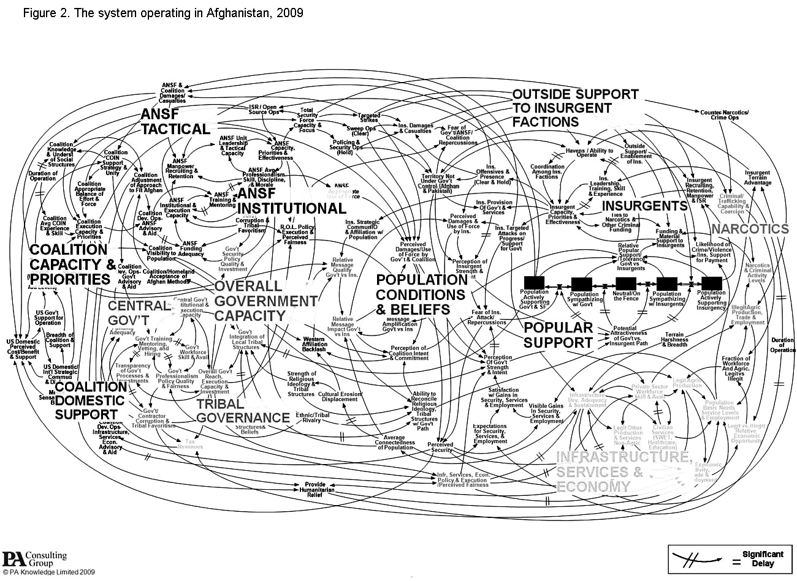

However, the complexity and abstraction of Senge's analysis may enable some readers to feel proud that they perceive issues and solutions that other people cannot see, and so these properties contribute to the development of a collectivity of superior insiders who appreciate Senge's message. The support organization Senge created, The Society for Organizational Learning, has already drifted away from the ideas in The Fifth Discipline. The Society has recently been promoting "Theory U" which promises to teach us "to connect to our essential Self in the realm of presencing" and to use "principles and practices that allow everyone to participate fully in co-creating and bringing forth the desired future that is working to emerge through us". Similarly, much of Senge’s own recent writing and speaking has centered on the more trendy topic of sustainability.
When Senge Said It: Is TLO Just a Fad or More than That?
Perhaps The Fifth Discipline has succeeded mainly because it fits into its time and place, because it captures the spirit of its age. In his forward to the 2006 edition of The Fifth Discipline, Senge explained that he had realized in 1987 "that 'the learning organization' would likely become a new management fad." He assumed that the fad would rise and fall and he wanted to establish key ideas early in the beginning of this fad and especially he wanted to influence the residual of ideas that remained after this fad abated.
Various commentators have declared TLO to be a short-term fad – indeed, a fad that is ending or has ended. Malone (1997) included TLO in a list of “management fads which have come and gone.” Hodgetts, Luthans and Lee (1998) claimed TLO was an intermediate stage in a developmental evolution toward "world-class organizations". Scarbourgh and Swan(2001) evaluated ProQuest references to "learning organization" and to "knowledge management" from 1990 to 1998, and concluded that TLO had become unfashionable and had been replaced by knowledge management. Rebelo and Gomes (2008: 294) inferred that "academic and managerial interest in these [organizational learning and TLO] started to wane slightly and the suspicion that organizational learning was merely a fashion has increased, as have the critical voices around it.”
Nevertheless, data do not yet demonstrate clearly that enthusiasm for TLO has waned. Figures 3a, 3b, and 3c compare the popularity of TLO with two management ideas that were popular from 1990 to 2005 – "six sigma" quality improvement and the "balanced scorecard" assessment of business performance. The graphs show the numbers of documents that cited The Fifth Discipline and the numbers of documents that used the phrases "learning organization," "six sigma" or "balanced scorecard". Figure 3a presents absolute numbers; many more documents used the phrase "learning organization" than used the phrases "six sigma" or "balanced scorecard." Only 40% of the documents that used the phrase "learning organization" also mentioned Senge; "learning organization" is a broader concept than Senge's TLO.
To highlight the different shapes of the curves, Figure 3b shows data normalized so that all four lines appear to describe the same total number of documents over the sixteen years, and Figure 3c shows changes averaged over three years.

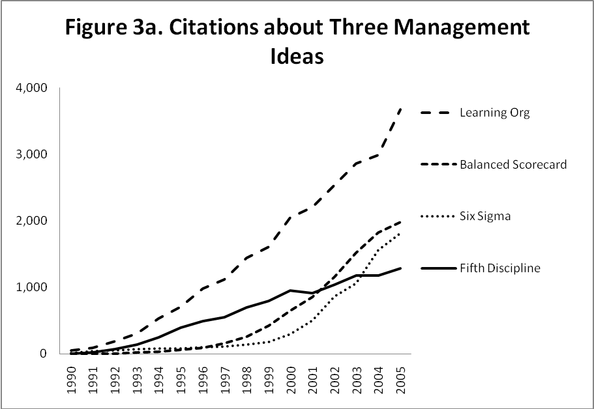
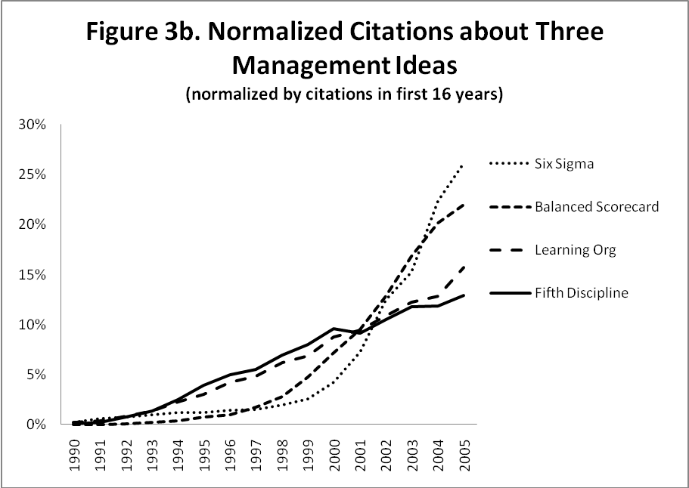
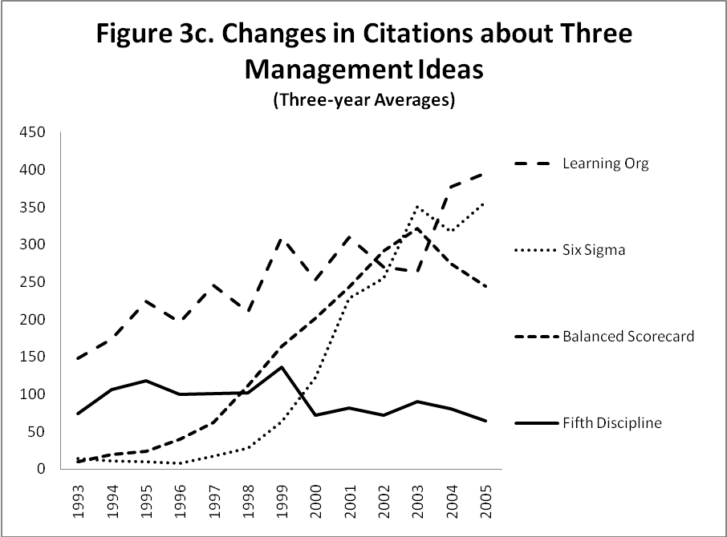
Citations to The Fifth Discipline and documents that mention "learning organization" have increased more linearly than documents that mention the other two management ideas. Both six sigma and the balanced scorecard drew very few citations during the early 1990s; then both began rapid growth just before 2000. Rapid growth could be a sign that people are becoming more likely to do something as they see more people doing it, possibly because prevalence confers legitimacy. When people or organizations adopt an innovation partly because many other people or organizations have adopted this innovation, a bandwagon effect occurs. On the other hand, some studies have shown that rapid growth in the adoption of an innovation correlated with a parallel increase in marketing efforts, and Abrahamson and Rosenkopf (1993) ran simulations that showed very small differences could have massive impacts on the rise and collapse in the popularity of innovations. It is also worthwhile to beware of fallacious inferences about the processes that generate time series: a given process can generate quite different specific series; different processes can generate similar series (Starbuck, 2006: 25-26).
Citations to The Fifth Discipline rose very linearly; the annual increases in citations were nearly constant from 1993 to 2005. Uses of the phrase "learning organization" were somewhat less linear in that the annual increases in citations grew larger over time, approximately doubling over ten years. Mainly linear growth might reflect a gradual opening up of multiple new markets, and this interpretation is consistent with some of the shifting currents in the kinds of people who have cited The Fifth Discipline. All the earliest citations came from documents in the English language, and as time passed, citations appeared in more and more languages. Loosely, one could say that the languages migrated from developed economies toward developing economies. There have also been adoption currents related to occupational groupings. For example, many citations have come from documents written by US Naval personnel and very few citations have come from documents written by other military personnel. Nurses have also shown special interest in The Fifth Discipline. Although each of these occupational groupings probably did engage in some bandwagon adoptions, each occupational grouping adopted TLO rather separately. With little contagion across groupings, exponential growth was restrained by boundaries between occupations, societies, and languages.
There is no clear reason why six sigma and balanced scorecard began spreading rapidly around 2000. Both ideas had been latent in the business culture for several decades, and although there were triggering events that brought them to the forefront, such triggering events could have happened much earlier or much later. The idea that businesses should consider factors other than financial ones originated in France in the early twentieth century, and General Electric developed a multidimensional assessment system for its profit centers during the 1950s. A 1992 article in Harvard Business Review gave balanced scorecard new visibility, but Harvard Business Review publicizes many ideas every year and 1992 was several years before the interest in balanced scorecard began to accelerate. Very high quality became a popular theme in Japan during the 1960s, and this theme spread world-wide during the 1970s when it appeared that Japanese companies were having remarkable success. During the 1960s, statistical studies of the PIMS database (Profit Impact of Market Strategy) indicated that high-quality products are often very profitable. Then, in the 1980s, Motorola Corporation combined long-standing ideas about how to raise quality into a formal training program that the corporation marketed under the "Six Sigma" trademark. For Motorola's corporate clients, six sigma offered easy implementation, quantitative measures of results, as well as some terminological pizzazz. However, Motorola's marketing of six sigma began almost two decades before interest in the idea began to accelerate.
Organizational learning is different. It seems quite unlikely that this idea could have started to become very popular before 1990. Although academics had written about organizational learning as early as the late 1950s, such ideas did not migrate into the literature of business practitioners. The phrase "organizational learning" did not appear in Harvard Business Review until 1989 and it appeared in Sloan Management Review only once before 1991.
Senge's TLO is a poor candidate for exponential growth based on imitation. Imitation of managerial ideas is more likely if the ideas are easy to comprehend, quick to implement, and capable of producing visible results. Senge's ideas are sufficiently abstract that many people do not see their value and they are difficult and expensive to implement (Smith, 2008). Senge provides no simple prescriptions, and he advocates long-term, persistent commitment to unusual social processes. The benefits of TLO are elusive; there is no way to find out what would have happened in the absence of TLO. Thomas and Allen (2006) pointed to a lack of clear connection between learning and business success, and Smith said that some converts to TLO eventually shifted to other approaches after evidence of business success with TLO was not forthcoming.
The Fifth Discipline may continue to attract audiences less because it provides easy solutions than because it addresses challenging issues of current relevance. The book deals with management issues that have been becoming more and more relevant in affluent, developed economies during the late twentieth century. These issues seem likely to continue to gain relevance over the coming decades.
Senge wrote about a complex world, with many interdependencies – oligopolistic markets, corporations and governments that cooperate, externalities. The populace of this world do not have to scrabble for existence and they aspire to do more than merely adapt to their environments; they reflect on their motives and actions and they seek to construct worlds with properties they desire. Workers are not lonely farmers at the mercy of weather or factory workers keeping pace with conveyor belts; they cooperate in teams, exchange ideas, analyze, and strategize.
Through the twentieth century, agriculture and manufacturing migrated toward developing economies, while the developed economies have shifted toward services. In the developed economies, the fastest-growing occupations have included professional and technical workers and managers. The US provides an extreme case. By 1990, the information sector accounted for three-fourths of US GNP, and over half of US workers were doing some type of information work.
Business in developed economies has been changing conceptually. New kinds of knowledge-intense and information-intense organizations have emerged that are devoted entirely to the production, processing and distribution of information (Starbuck, 1992). These new kinds of organizations already employ many millions of people, with the Internet supporting new business and career opportunities. As well, facilitated by better telecommunications, business firms have been creating alliances and forming networks, and these larger entities have given business strategists license to think more about constructing environments that they desire instead of adapting to environments that already exist. Current thinking about strategic management emphasizes the usefulness of valuable resources that are rare and difficult to imitate (Barney, 1991), and many organizations seek to accumulate valuable and proprietary knowledge that they can exploit strategically. For instance, chemical and pharmaceutical companies employ skilled scientists and spend heavily on research aimed at developing proprietary products. Some manufacturing firms see experienced and highly trained managers as key assets, and many firms have appointed “learning officers” who are charged with identifying useful knowledge and disseminating it to personnel who can use it. Managements have shifted focus from more traditional input-and-output analysis to deal with knowledge capital, information systems, logistics, and supply chains.
Senge saw these trends and responded to them, and it is unclear what forces might deflect changes from following the trends. It seems likely that information and knowledge will grow more and more important in developed economies. In particular, despite the fact that computers and electronic communications devices have existed for decades and they have become quite prevalent in Europe, Japan, and North America, only a fraction of the world population has use of computers, e-mail, or the Internet. At the same time, technological development has been accelerating. Organizations have been gaining access to more data more quickly. As this creates opportunities for surveillance from afar, competitive intelligence has been becoming easier and more productive, supervisors can more easily monitor distant subordinates, and organizations can more easily monitor their alliance partners. The technology also gives organizations more freedom to spread geographically, and they can collaborate effectively without actually merging.
What Research into Fads and Fashions Says About TLO's Success
TLO's history illustrates the rise in popularity and dissemination of a body of ideas, a particular way of thinking. Research about fads and fashions can make some interpretations of TLO's history more plausible and others less plausible. However, the history of TLO differs from most of the fads and fashions that researchers have studied. This means that much prior research is only indirectly relevant and it also suggests some opportunities for future research.
The terms fad and fashion encompass a wide variety of social phenomena. They may spread across large populations of people or organizations, or they may occur within individual organizations or small subpopulations. Many business techniques have had very short life cycles (Brandes, 1976; Carson et al., 2000). By contrast, Aristotle's ideas dominated western thinking about physics for over two millennia. As well, fads and fashions produce a wide variety of consequences, some beneficial and some harmful, some short-term and others long-term. Indeed, fads and fashions are kinds of social change, and change can be positive or negative, rapid or slow. Abrahamson and Rosenkopf (1993, 1997) characterized fads as forms of social change that incorporate contagion, and fashions as forms of social change in which followers imitate fashion setters.
It is helpful to consider fads and fashions as commodities bought and sold in markets. Some people and organizations act as buyers and others as sellers. A market perspective calls attention to some of the social structures that facilitate buying and selling and methods used to sell ideas. A market perspective aids in understanding the emergence of a fad and explains differences in popularity of some fads.
The Market for Business Techniques
Senge's ideas about TLO and more general ideas about the "learning organization" are so ambiguous that they may not qualify as business techniques. They are less specific than many of the techniques that have been studied. However, research about fads and fashions in business techniques provides suggestions about the processes affecting the popularity and consequences of TLO.
Abrahamson (1996) analyzed changes in business techniques in a market framework. The techniques bought and sold in this market bear labels – such as "The Learning Organization" – that provide concise characterizations for bundles of ideas, methods, requirements, and limitations that may be quite complicated. Both sellers and buyers of popular business techniques characterize them as "rational" and "progressive." That is, the techniques supposedly help business firms and other organizations to efficiently transform inputs into highly desirable outputs, and the techniques supposedly improve on previous techniques. The emphasis on progressive improvement guarantees that techniques will be constantly changing and that the sellers of techniques will claim that newer techniques are better.
Meyer and Rowan (1977) pointed out that criteria for judging rationality or improvement may have weak substantive support; there may be little or no clear evidence about efficiency, effectiveness, or benefits. However, the criteria have support from social norms. On the supply side, new techniques may allow consulting firms and gurus who market them to claim specialized expertise. On the demand side, stakeholders may withdraw support from organizations that do not use fashionable business techniques, and stakeholders may confer benefits on organizations that do adopt the latest techniques. Stakeholders may pursue fleeting opportunities or espouse new myths about organizational effectiveness (Abrahamson, 1996). Of course, societies differ in the degrees to which they value progressive change (Rogers, 1962). Competitive markets emphasize progressive change because competitors have to out-do each other (Campbell, 1985; Van Valen, 1973).
Several studies have found that claims about the effectiveness of new business techniques have very often been deceptive in that the buyers made little or no pragmatic use of the techniques (Staw and Epstein, 2000; Wang, 2010). For instance, Zbaracki (1998) found that the Total Quality Management (TQM) label was associated with very limited pragmatic use of TQM’s prescriptions, and the superficial pragmatic use of prescriptions that did occur generally yielded poor results. However users hid the poor results behind various organizational facades (Nystrom and Starbuck, 2006), and then told stories of TQM’s successful implementation. Westphal, Gulati, and Shortell (1997) inferred that, among 2700 hospitals using TQM, early users showed a few performance increases, whereas later users tended to communicate TQM’s use only for the rhetorical benefits they obtained. Chevalier’s (1991) study of use of the Quality Circle (QC) label revealed two types of scenarios. In one scenario, each organization made very limited pragmatic use of QC’s prescriptions but hid the lack of pragmatic use from stakeholders. In the second scenario, managers adopted behavioral approaches that fit their organizations’ idiosyncrasies but that had little to do with QC’s prescriptions. Delacroix and Swaminathan (1991) concluded that nearly all organizational changes in the California wine industry are cosmetic, pointless, or speculative.
For there to be significant changes in business techniques, there must be large numbers of buyers of these techniques, which in turn means that there must be even larger numbers of potential buyers (Abrahamson and Fairchild, 1999). One way for a pool of potential buyers to develop is for a new technique to produce genuinely much better solutions to pervasive problems. Although the sellers of new techniques typically claim that their techniques do this, the evidence cited above suggests that the claims rarely have justification. Because people have been redesigning and adapting organizations for a very long time, the chances are remote of coming up with a genuinely original idea.
A second way for a pool of potential buyers to develop is for buyers of an existing technique to gradually lose confidence in it. In part because they face mutually inconsistent demands from different stakeholders, managers are endlessly trying to "solve" some intrinsic organizational problems that have no solutions (Starbuck, 1994). As a result, techniques that supposedly solve these unsolvable problems inevitably disappoint those who have bought them. As the disappointed buyers accumulate, they become potential buyers of new solutions for the corresponding unsolvable problems. Abrahamson and Fairchild (1999) found that people talk about fads and fashions in more positive and emotional language while adopters are increasing, whereas the talk becomes more negative and logical while adopters are decreasing (Jönsson and Lundin, 1977).
A third way for a pool of potential buyers to develop is for social or technological evolution to create new organizational problems. The later part of the twentieth century brought many, many new organizational problems. Because agriculture and manufacturing industries compete with their counterparts in economies with lower wage levels, developed economies did less and less farming and manufacturing and shifted toward service industries that take advantage of education. In developed economies, and especially in the US, workers' educational levels rose dramatically. Because educated workers want autonomy and resent direct supervision, employers placed more emphasis on teamwork; team members supervise each other. Of course, the demand for organizations to "learn" is partly one of those unsolvable organizational problems: To know what is worth learning requires coping with great complexity and predicting the future rather accurately. Therefore, Senge could not propose a lasting solution. He could however propose a solution that utilized computers and that would appeal to more highly educated workers who know how to collaborate in teams.
The Marketing of Business Techniques
Because social norms exert very strong influence in the market for fads and fashions, language and appearances are key properties in promoting success. Some fads and fashions also gain impetus from characteristics of their purveyors, including academics, consulting firms, and gurus.
A technique's name matters. "The learning organization" sounds more proactive and progressive than "the adaptive organization" or "the reactive organization." "Six sigma" sounds quantitative and scientific, and quality-improvement personnel who bear the labels "black belt" or "green belt" certainly sound like they are capable of significant accomplishments. Buyers of business techniques use labels to communicate to their stakeholders that their organizations are using progressive, rational business techniques.
Jackson (1995: 38) commented, “fads tend to recommend solutions which they believe hold in all circumstances”. Prescriptions that allow for many interpretations can be very successful. Organizations can clarify, particularize, and use such advice pragmatically in very different ways to fit various idiosyncrasies, from geographic locations (Giroux, 2006; Kieser, 1997) to distinctive swaths of time in different organizational sectors (Morris and Lancaster, 2006) or nations (Czarniawska-Joerges and Sevón, 2005). However, potential adopters also want or need easy-to-use tools that facilitate initial steps toward implementation. Many purveyors of business techniques supply tools for information gathering or self-training – questionnaires, forms, frameworks for discussing concepts – and many purveyors offer training.
The purveyors of business techniques come in at least three varieties. Academics come up with quite a few proposals about business techniques, but nearly all of these proposals lack easy means of implementation so they attract few adoptions. One exception to this pattern was a proposal by Richard Hackman, Ed Lawler, and Greg Oldham to "enrich" jobs. Academic and mass-market publications by these academics included reports of field research that gave credibility to their ideas and questionnaires for assessing the characteristics of jobs (Hackman and Lawler, 1971; Hackman and Oldham, 1980). As a result, thousands of human-resources departments around the world used the questionnaires and attempted to redesign jobs.
Other purveyors are consultants. Consultants are continually searching for services that will entice clients to hire them (Kieser, 2001). Consultants perform activities such as information gathering and training that convert ideas into actions that appear practical. For example, in 1970, the Boston Consulting Group (BCG) began to advocate that a company should have a balanced portfolio of business activities that include (a) "stars" with high market shares and high growth, (b) "cash cows" that generate profits, and (c) "question marks" that have potential to become stars. BCG's staff offered to put on strategic planning sessions to help client firms diagnose their existing strategic portfolios and to develop scenarios for future development. However, BCG gained limited advantage from its schema because it was so appealing, easily understood, and superficially logical that many other consultants imitated it and it appeared in all of the strategic management textbooks.
Many new business techniques, although not all, have support and stimulus from gurus (Abrahamson and Fairchild, 1999; Gill and Whittle, 1993). To be perceived as a guru, someone has to be a compelling spokesperson. Some gurus also serve as living symbols of the ideas they promote. However, all gurus have human defects and these defects sometimes undermine enthusiasm for their techniques. Peter Senge has been formally anointed as a world-class guru by the Financial Times and Business Week, and he exhibits some characteristics that reinforce TLO and some that do not. His photo on the cover of The Fifth Discipline portrays him as boyish and idealistic, and in person, he comes across as sincere and optimistic. However, his workbooks did not provide easily used implementation tools, and his efforts to create delivery systems for TLO have been less than successful. The Center for Organizational Learning at MIT, which Senge created in 1991, did not deliver solutions; rather it encouraged two score companies to attempt various experiments. Next, in 1997, Senge founded the Society for Organizational Learning, but the members of this society seem to have drifted away from Senge's own ideas.
In general, research indicates that adoption of new business techniques involves strong reliance on rhetoric, weak results hidden behind facades, and strong claims of success (Hirsch, 1986; Strang and Macy, 2001; Strang and Meyer, 1994). Some business techniques involve easy-to-use implementation tools, other techniques offer very general prescriptions that adopters can interpret in many ways. Senge's affiliation with a prestigious academic institution, the complexity of his prescriptions, the jargon and scientific appearance of systems analysis, his emphasis on honesty, forthrightness, and collaboration, all give the TLO label a cachet. Yet, the idealism is so strong that very few people, if any, would try to implement TLO as Senge prescribes it. Indeed, Senge himself stated that he was talking about a kind of organization that could possibly exist someday in the future. Senge's audiences have expressed uncertainty about what TLO entails. Worrell (1995: 353) characterized the “complete learning organization” of Senge's design as “more of an ideal than a reality” and noted that firms had been adopting only one or two elements of TLO, not the entire package. Ortenblad (2007) collected some very diverse definitions of TLO, which led him to liken dissemination of the concept to children's “whisper-down-the-lane” game. He remarked that people cite different passages from The Fifth Discipline, which, he said, leaves room for dynamic thinking and inspiration. Smith (2008) also commented that lack of clarity of the concept allows managers, researchers, students and even editors make TLO into what they wish.
Fluid Knowledge
All knowledge is imperfect and incomplete. Societies, human capabilities, social relations, resources, technologies, all change. Even very ancient ideas have to be restated in modern language and metaphors to make them meaningful to the current age. Thus, how knowledge evolves is more important than what knowledge exists already.
Fads and fashions are media for knowledge development. They are a societal form of brainstorming where people try on new ideas, often quickly discarding those that do not work well; yet retaining others. Fads and fashions are processes by which knowledge accumulates and spreads. They draw upon aspirations, enthusiasm, fear, greed, mass media, social influence, and social pressure to inform people about new ideas and to induce them to investigate the value of these new ideas. Fads and fashions also make people aware that knowledge deteriorates, and they facilitate the discarding of obsolete ideas. People who discover the deficiencies of old ideas do so gradually and surrounded by other people who are making similar discoveries. The prevalence of so many fads and fashions provides constant reminders that knowledge is transitory, and there are usually several alternative ideas being offered as replacements for obsolete older ones (Abrahamson and Fairchild, 2009; Scarbrough and Swan, 2001).
At a microscopic level, the very process of change both produces knowledge and obsoletes it. As people attempt change, they take fresh looks at what they have been doing, they develop new perceptions and make discoveries, and some of these have lasting value. The discoveries include deficiencies in older knowledge, and the process of discovery can be exhilarating. As a result, adoption of a new business technology can improve performance even if the new technology per se is not a meaningful improvement or if the "technology" is a very ambiguous assortment of ideas with little practical content (Ogbonna and Harris, 2002). People who are struggling with very difficult, possibly unsolvable, problems need visions of possible improvement to keep them going.
Fads and fashions not only help to update knowledge; they help to formulate future knowledge by fostering mutation (Heusinkveld and Benders, 2001). Benders and Van Veen (2001: 37) argued that "a certain degree of conceptual ambiguity" gives a business technique “interpretive viability” that frees adopters to users redefine what the technique means and entails. Senge's TLO possesses such conceptual ambiguity (Ortenblad, 2007). Jackson (2000: 207) inferred that The Fifth Discipline uses stories, parables, and well-established theoretical arguments to dramatize a “socially rooted vision” that encourages readers to see themselves as “actively engaged in building a learning organization.” TLO captures the fluidity of knowledge. Even if a fad, it is capable of dispersing and seeping into the very pours of a firm. By choosing among the book's numerous stories and aphorisms, readers can adapt TLO to a multitude of complex contexts.

REFERENCES
Abrahamson, E. (1996) Management fashion. Academy of Management Review, 21(1): 254-285.
Abrahamson, E. and Eisenman, M. (2008) Employee management techniques: Transient fads of trending fashions. Administrative Science Quarterly, 53(4): 719-744.
Abrahamson, E. and Fairchild, G. (1999) Management fashion: Lifecycles, triggers and collective learning processes. Administrative Science Quarterly, 44: 708-740.
Abrahamson, E. and Rosenkopf, L. (1993) Instititional and competitive bandwagons: Using mathematic modeling as a tool to explore innovation diffusion. Academy of Management Review, 18(3): 487-517.
Abrahamson, E. and Rosenkopf, L. (1997) Social network effects on the extent of innovation diffusion: A computer simulation. Organization Science, 8(3): 289-309.
Argote, L. (1999) Organizaional Learning: Creating, Retaining and Transferring Knowledge. Boston: Kluwer.
Argyris, C. (1982) Reasoning, Learning and Action: Individual and Organizational. San Francisco: Jossey-Bass.
Argyris, C. and Schön, D.A. (1978) Organizational Learning: A Theory of Action Perspective. Reading, MA: Addison Wesley.
Ashby, W.R. (1958) Requisite variety and its implications for the control of complex systems. Cybernetica, 1(2): 83-99.
Barney, J. (1991) Firm resources and sustained competitive advantage. Journal of Management, 17 (1): 99-120.
Baumard, P. and Starbuck, W.H. (2005) Learning from failures: Why it may not happen. Long Range Planning, 18 (3): 281-298.
Benders, J. and Van Veen, K. (2001) What’s in a fashion? Interpretive viability and management fashions. Organization, 8(1): 33-53.
Bohm, D. (1965) The Special Theory of Relativity. New York: W.A. Benjamin.
Box, G.E.P. and Draper, N.R. (1969) Evolutionary Operation. New York: Wiley.
Brandes, S. (1976) American Welfare Capitalism, 1880-1940. Chicago: University of Chicago Press.
Bumiller, E. (2010) We have met the enemy and he is PowerPoint. The New York Times, April 26: 1.
Campbell, J.H. (1985) An organizational interpretation of evolution. In D. J. Depew and B. H. Weber (eds.), Evolution at a Crossroads: The New Biology and the New Philosophy of Science. Cambridge, MA: MIT Press, 133-168.
Carroll, G.R. (1983) A stochastic model of organizational mortality: Review and reanalysis. Social Science Research, 12 (4): 303-329.
Carson, P., Lanier, P. A., Carson, K. D. and Guidry, B. N. (2000) Clearing a path through the management fashion jungle: Some preliminary trailblazing. Academy of Management Journal, 43(6), 1143-1158.
Chevalier, F. (1991) From quality circles to total quality. International Journal of Quality & Reliability Management, 8(4): 9-24.
Cyert, R.M. and March, J.G. (1963) Behavioral Theory of the Firm. Englewood, NJ: Prentice Hall.
Czarniawska-Joerges, B. and Sevón, G. (2005) Global Ideas: How Ideas, Objects and Practices Travel in a Global Economy. Malmö, Sweden: Liber & Copenhagen Business School Press.
de Geus, A.P. (1988) Planning as learning. Harvard Business Review, 66 (2): 70-74.
Delacroix, J. and Swaminathan, A. (1991) Cosmetic, speculative, and adaptive organizational change in the wine industry: A longitudinal study. Administrative Science Quarterly, 36: 631-661.
Faust, D. (1984) The Limits of Scientific Reasoning. Minneapolis: University of Minnesota Press.
Forrester, J. (1961) Industrial Dynamics. Cambridge, MA: MIT Press.
Forrester, J. (1969) Urban Dynamics. Cambridge, MA: MIT Press.
Forrester, J. (1971) The counterintuitive behavior of social systems. Technology Review, 73 (3): 52-68.
Fritz, R. (1989) The Path of Least Resistance. New York: Fawcett-Columbine.
Garratt, B. (1987) The Learning Organization. London: Fontana Paperbacks.
Gill, J. and Whittle, S. (1993) Management by panacea: Accounting for transience. Journal of Management Studies, 30: 281-295.
Giroux, H. (2006) “It was such a handy term”: Management fashions and pragmatic ambiguity. Journal of Management Studies, 43(6): 1227-1260.
Goldberg, L.R. (1970) Man versus model of man: A rationale, plus some evidence, for a method of improving on clinical inference. Psychological Bulletin, 73: 422-432.
Hackman, J.R. and Lawler, E.E. (1971) Employee reactions to job characteristics. Journal of Applied Psychology Monograph, 55: 259-286.
Hackman, J.R. and Oldham, G.R. (1980) Work Redesign. Reading, MA: Addison-Wesley.
Hardin, G. (1968) The tragedy of the commons. Science, 162: 1243-1246.
Hedberg, B.L.T., Nystrom, P.C. and Starbuck, W.H. (1976) Camping on seesaws: Prescriptions for a self-designing organization. Administrative Science Quarterly, 21 (1): 41-65.
Heisenberg, W. (1971) Physics and Beyond: Encounters and Conversations. New York: Harper and Row.
Heusinkveld, S. and Benders, J. (2001) Surges and sediments: Shaping the reception of engineering. Information & Management, 38(4): 239-251.
Hirsch, E.L. (1986) The creation of political solidarity in social movement organzations. Sociological Quarterly, 27(3): 373-387.
Hodgetts, R.M., Luthans, F. and Lee, S.M. (1998) New paradigm organizations: From total quality to learning to world-class. Organizational Dynamics, 22(3), 5-19.
Inamori, K. (1985) The perfect company: Goal for productivity. Speech given at Case Western Reserve University, June 5.
Jackson, B.G. (2000) A fantasy theme analysis of Peter Senge’s learning organization. The Journal of Applied Behavioral Science, 36(2): 193-209.
Jackson, M.C. (1995) Beyond the fads: Systems thinking for managers. Systems Research, 12(1): 25-42.
Jönsson, S.A. and Lundin, R.A. (1977) Myths and wishful thinking as management tools. In P.C. Nystrom and W.H. Starbuck (eds.), Prescriptive Models of Organizations. Amsterdam: North-Holland, 157-170.
Kaufman, Jr., D. (1980) Systems 1: An Introduction to Systems Thinking. Minneapolis: Future Systems Inc.
Kieser, A. (2001) Applying theories of fashion to management consulting: How consultants turn concepts into fashions and sell them to managers. Academy of Management Proceedings, Best Papers.
Korten, D.C. (1980) Community organization and rural development: A learning process approach. Public Administration Review, 40 (5): 480-511.
Levinthal, D. (1991) Random walks and organizational mortality. Administrative Science Quarterly, 36: 397-420.
Malone, M.S. (1997) A way too short history of fads. Forbes, 159(7): 72-72.
March, J.G. (2010) The Ambiguities of Experience. Ithaca, NY: Cornell University press.
Meehl, P.E. (1954) Clinical versus Statistical Prediction: A Theoretical Analysis and a Review of the Evidence. Minneapolis, MN: University of Minnesota Press.
Meyer, J.W. and Rowan, B. (1977) Institutionalized organizations: Formal structure as myth and ceremony. American Journal of Sociology, 83: 340-363.
Mitroff, I. (1988) Break-away Thinking. New York: John Wiley.
Morris, T. and Lancaster, Z. (2006) Translating management ideas. Organization Studies, 27(2): 207-233.
Nystrom, P.C. and Starbuck, W.H. (2006) Organizational facades. In W.H. Starbuck (ed.), Organizational Realities. Oxford: Oxford University Press, 201-208.
O'Brien, B. (1991) Advanced Maturity. Available from Hanover Insurance, 100 North Parkway, Worcester, MA 01605.
Ogbonna, E. and Harris, L.C. (2002) The performance implications of management fads and fashions: An empirical study. Journal of Strategic Marketing, 10 (1): 47-68.
Ortenblad, A. (2007) Senge’s many faces: problem or opportunity? The Learning Organization, 14 (2): 108-122.
Pedler M., Burgoyne J. and Boydell J. (1988) Learning Company Project: A Report on Work Undertaken October 1987 to April 1988. Sheffield: The Training Agency.
Rebelo, T.M. and Gomes, A.D. (2008) Organizational learning and the learning organization: Reviewing evolution for prospecting the future. The Learning Organization, 15 (4): 294-308.
Roberts, N. (1978) Teaching dynamic feedback systems thinking: An elementary view. Management Science, 24 (8): 836-843.
Roberts, N. (1983) Teaching the world with simulations. Classroom Computer News, Jan/Feb: 28.
Rogers, E.M. (1962) Diffusion of Innovation. New York: Free Press of Glencoe.
Revans, R.W. (1982) The enterprise as a learning system. In The Origins and Growth of Action Learning. London: Chartwell-Bratt.
Salgado, S.R., Starbuck, W.H. and Mezias, J.M. (2002) The accuracy of managers’ perceptions: A dimension missing from theories about firms. In M. Augier and J. G. March (eds.), The Economics of Choice, Change, and Organizations: Essays in Memory of Richard M. Cyert. Cheltenham: Edward Elgar, 168-185.
Scarbrough, H. and Swan, J. (2001) Explaining the diffusion of knowledge management: The role of fashion. British Journal of Management, 12 (1): 3-12.
Schön, D. (1983) The Reflective Practitioner: How Professionals Think in Action. New York: Basic Books.
Senge, P.M. (1990 and 2006) The Fifth Discipline: The Art and Practice of the Learning Organization. New York: Doubleday.
Senge, P. and Crainer, S. (2008) Senge and sensibility. Business Strategy Review, 19 (4): 71- 75.
Senge, P., Kleiner, A., Roberts, C., Ross, R. and Smith, B. (1994) The Fifth Discipline Fieldbook: Strategies and Tools for Building a Learning Organization. New York: Doubleday.
Senge, P., Kleiner, A., Roberts, C., Ross, R., Roth, G. and Smith, B. (1999) The Dance of Change: The Challenges to Sustaining Momentum in Learning Organizations. New York: Doubleday.
Senge, P., Cambron-McCabe, M., Lucas, T., Smith, B., Dutton, J. and Kleiner, A. (2000) Schools that Learn: A Fifth Discipline Fieldbook for Educators, Parents and Everyone who Cares about Education. New York: Doubleday.
Simon, H.A. and Bonini, C.P. (1958) The size distribution of business firms. American Economic Review, 48 (4): 607-617.
Smith, M.K. (2001) Peter Senge and the learning organization. The Encyclopedia of Informal Education. [www.infed.org/thinkers/senge.htm. Last update: September 3, 2009].
Smith, P.A.C. (2008) The Learning Organization turns 15: A retrospective. The Learning Organization, 15 (6): 441-448.
Starbuck, W.H. (1992) Learning by knowledge-intensive firms. Journal of Management Studies, 29 (6): 713-740.
Starbuck, W.H. (1994) On behalf of naïveté. In J.A.C. Baum and J.V. Singh (eds.), Evolutionary Dynamics of Organizations. London: Oxford University Press, 205-220.
Starbuck, W.H. (2006) The Production of Knowledge: The Challenge of Social Science Research. New York: Oxford University Press.
Starbuck, W.H. and Pant, P.N. (1996) Trying to help S&Ls: How organizations with good intentions jointly enacted disaster. In Z. Shapira , Organizational Decision Making. Cambridge: Cambridge University Press.
Staw, B.M. and Epstein, L.D. (2000) What bandwagons bring: Effects of popular management techniques on corporate performance, reputation and CEO pay. Administrative Science Quarterly, 45(3): 523-556.
Sterman, J. (1987) Misperceptions of feedback in dynamic decisionmaking. MIT Sloan School of Management Working Paper WP-1933-87.
Strang, D. and Macy, M.W. (2001) In search of excellence: Fads, success stories and adaptive emulation. American Journal of Sociology, 107(1): 147-182.
Strang, D. and Meyer, J.W. (1994) Institutional conditions for diffusion. In W. R. Scott and J, W, Meyer (eds), Institutional Environments and Organizations: Structural Complexity and Individualism. Newbury Park, CA: Sage, 100-112.
Sturdy, A. (1997) The consultancy process – An insecure business. Journal of Management Studies, 34 (3): 389-413.
Thomas, K. and Allen, S. (2006) The learning organization: A meta-analysis of themes in literature. The Learning Organization, 13 (2): 123-139.
Tuchman, B. (1984) The March of Folly: From Troy to Vietnam. New York: Knopf.
Van Valen, L. (1973) A new evolutionary law. Evolutionary Theory, 1: 1-30.
Wang, P. (2010) Chasing the hottest IT: Effects of technology fashion on organizations. Management Information Systems Quarterly, 34(1): 63-85.
Westphal, J.D., Gulati, R. and Shortell, S.M. (1997) Customization and conformity: An institutional and network perspective on the content and consequences of TQM adoption. Administrative Science Quarterly, 42: 366-394.

Worrell, D. (1995) The learning organization: Management theory for the information age or a new age fad? The Journal of Academic Librarianship, 21 (5): 351-357.
Yankelovich, D. (1981) New Rules: Searching for Self-fulfillment in a World Turned Upside Down. New York: Random House.
Zbaracki, M.J. (1998) The rhetoric and reality of total quality management. Administrative Science Quarterly, 43(3): 602-636.

